* **Config project**

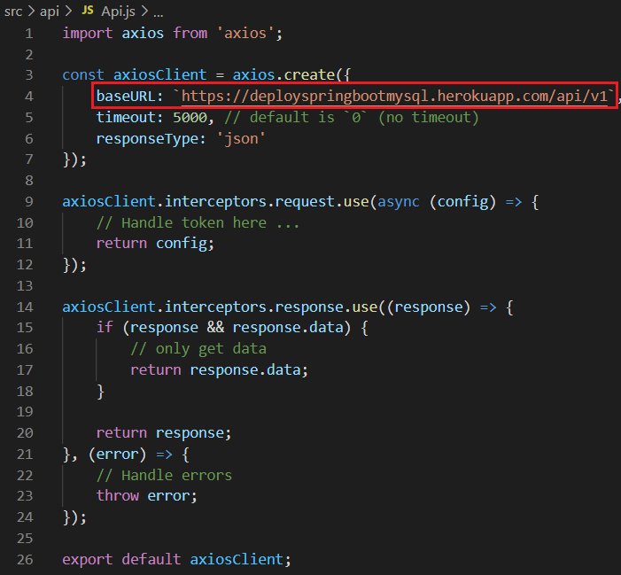

*Config Link API*

* **Push code lên Git**

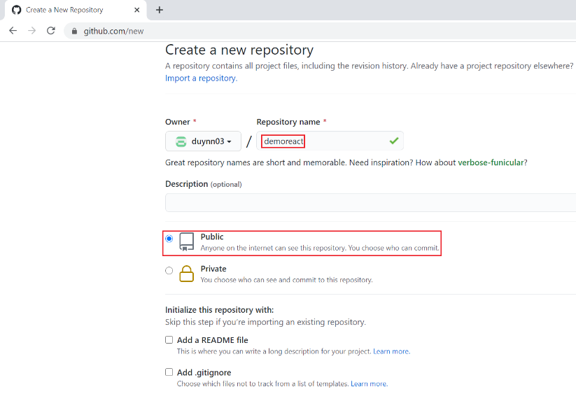

*Tạo Repository Git*

|  |  |
| --- | --- |
|  |  |

git remote add origin [*https://github.com/duynn03/demoreact.git*](https://github.com/duynn03/demoreact.git)

git remote -v

git add .

git commit -m "*message*"

git push -u origin *master*

*Link Local Repository với Remote Repository, sau đó Push code lên Git*

* **Connect Git với Heroku và deploy**

|  |  |
| --- | --- |
|  |  |

[*https://dashboard.herokuapp.com/*](https://dashboard.herokuapp.com/login)

*Tạo app trên heroku*

|  |  |
| --- | --- |
|  |  |

*Kết nối Heroku với Repository Git*

|  |  |
| --- | --- |
|  |  |

*Deploy*

|  |  |  |
| --- | --- | --- |
|  |  |  |

*Demo*

* **Reference**

<https://levanlau.com/vi/blog/post-list/how-to-deploy-reactjs-app-to-heroku-dot-com/>